November 6, 2008

PRESS RELEASE-ADVISORY
– FOR IMMEDIATE RELEASE –

DEDICATION CEREMONY –
November 13th, 2008, at 1:30 p.m. at 63/71 BATTLE STREET in SOMERS, CT

STATE OF CONNECTICUT CONTINUES 40-YEAR PARTNERSHIP

COMMUNITY COMES TOGETHER TO DEDICATE
NEW WOODCREST AFFORDABLE ELDERLY BUILDING

FACILITY FEATURES 34 HIGH-QUALITY RENTAL UNITS

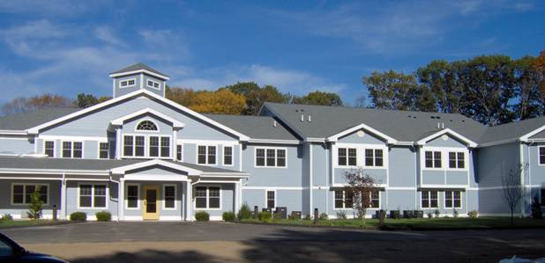
Developer Consultant: Real Estate Diagnostics Inc. Architect: Henry Schadler Associates, PC General Contractor: ALCA Construction Co.

Joan McDonald, Commissioner of the State Dept. of Economic and Community Development (DECD), will be the Honored Guest and Keynote Speaker at this event.

In addition, the Dedication Ceremony guests will include State Representative Penny Bacchiochi; State Senator John Kissel; Timothy Coppage, Senior Vice-President of the Connecticut Housing Finance Authority; David Pinney, First Selectman of the Town of Somers; William DeMore, Vice-President of the Rockville Bank; Kenneth Willis, Senior Vice President of the Federal Home Loan Bank of Boston; Mary Stoddard of SunAmerica Affordable Housing Partners, and other distinguished guests. Brian DuPerre, Chairman of the Somers Housing Authority, will host the event.

The dedication ceremony will be held at 1:30 p.m. on November 13th, at 63/71 Battle Street in Somers, CT.

The public is welcome, and refreshments will be served.

The event will feature a dedication ceremony to celebrate the completion of construction on the new “Woodcrest Center” building, which contains 34 units of quality elderly rental housing. All of these modern, comfortable units will be rented to low- and moderate-income elderly tenants.

This initiative is being sponsored by the Somers Housing Authority, and represents a partnership involving the Town of Somers, the State of Connecticut Department of Economic and Community Development, the Rockville Bank,
the Connecticut Housing Finance Authority, the Federal Home Loan Bank of Boston, Northeast Utilities, SunAmerica Affordable Housing Partners, and the Connecticut Housing Investment Fund.

The Town of Somers donated the land for this development. The Developer Consultant is Real Estate Diagnostics Inc., the Architect is Henry Schadler Associates, and the General Contractor is ALCA Construction Company.
Contact:
Harvey Edelstein, President
(203-481-6734)
harveye@realestatediagnostics.net


Real Estate Diagnostics Incorporated p.203-481-6734 f. 203-481-3399 www.realestatediagnosticsinc.com

